The utility of different acoustic indicators to describe biological sounds of a coral reef soundscape

Sean Dimoff¹, William D. Halliday^{1,2*}, Matthew K. Pine¹, Kristina L. Tietjen¹, Francis Juanes¹, Julia K. Baum^{1,3*}

¹Department of Biology, University of Victoria, PO Box 1700 Station CSC, Victoria, British Columbia, V8W 2Y2, Canada

²Wildlife Conservation Society Canada, 169 Titanium Way, Whitehorse, Yukon, Y1A 0E9, Canada

³Hawai‘i Institute of Marine Biology, University of Hawai‘i, 46-007 Lilipuna Road, Kāne‘ohe, Hawai‘i, 96744, USA

*Corresponding Authors: whalliday@wcs.org; baum@uvic.a

Supplementary Materials

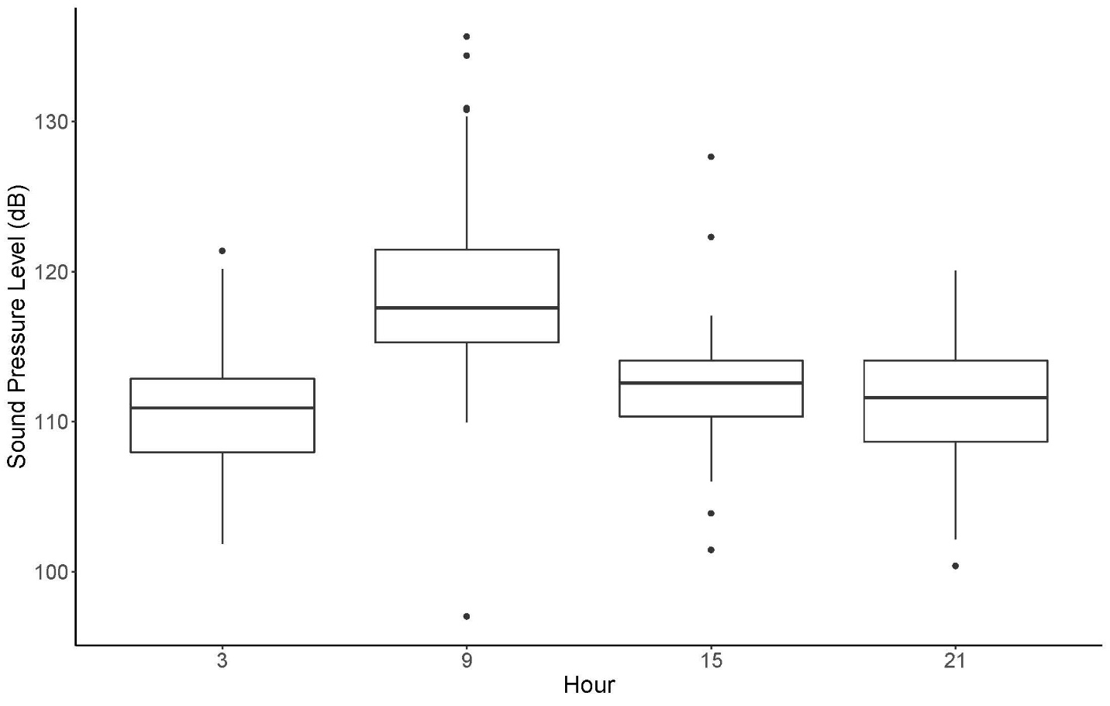
Supplementary Figure 1. Differences in Sound Pressure Level (dB) between the four sampled times of day using subsampled individually selected knocks.

Supplementary Table 1. Top models from AIC_{c} stepwise comparisons and results (parameter estimates) for final model fixed effects from linear mixed-effects model examining changes in high frequency SPL associated with changes in snapping shrimp snaps.
Model |  |  | K | AICc |  | ΔAIC |  | Adjusted R² | P value
HF SPL ~ Snaps * Day/Night + Year + Lunar Phase + Fishing Pressure |  |  | 8 | 77923.39 |  | 0 |  | 0.371 | < 0.0001
HF SPL ~ Snaps + Day/Night + Year + Lunar Phase + Fishing Pressure |  |  | 7 | 78034.51 |  | 111.11 |  | 0.367 | < 0.0001
HF SPL ~ Snaps + Year + Lunar Phase + Fishing Pressure |  |  | 6 | 79819.11 |  | 1895.72 |  | 0.292 | < 0.0001
Parameter estimates for final model
Parameter | Estimate | Std. Error |  |  | t value |  | P value
(Intercept) | 114.94 | 0.034 |  |  | 3354.404 |  | < 0.0001
Snaps | 0.87 | 0.059 |  |  | 14.696 |  | < 0.0001
Day/Night (Night) | 1.92 | 0.044 |  |  | -8.868 |  | < 0.0001
Snaps * Day/Night | 0.21 | 0.045 |  |  | 10.652 |  | < 0.0001
Lunar Phase | 3.40 | 0.046 |  |  | 4.767 |  | < 0.0001
Year (2018) | 1.00 | 0.045 |  |  | 74.472 |  | < 0.0001
Fishing Pressure | 0.97 | 0.092 |  |  | 22.314 |  | < 0.0001

Supplementary Table 2. Parameter estimates for the selected low frequency ACI model calculated using a frequency resolution of 15.6 Hz. Fixed effects from linear mixed-effects model examining changes in ACI associated with changes in snapping shrimp snaps. The intercept and all main effects represent our 15:00 sampling time.

15.6 Hz Frequency Resolution Model
LF ACI ~ Knocks * Hour + Herbivory + Year + Lunar Phase + Fishing Pressure
Parameter estimates for final model
Parameter | Estimate | Std. Error | t value | P value
(Intercept) | 35.962 | 0.234 | 153.386 | < 0.0001
Knocks | 0.756 | 0.505 | 1.497 | 0.136
21:00 | -0.161 | 0.268 | -0.603 | 0.547
03:00 | 1.178 | 0.276 | 4.263 | < 0.0001
09:00 | 0.038 | 0.278 | 0.136 | 0.892
Herbivory | 0.740 | 0.186 | 3.970 | 0.0001
Lunar Phase | -0.058 | 0.182 | -0.318 | 0.751
Year (2018) | 0.216 | 0.164 | 1.315 | 0.190
Fishing Pressure | 1.308 | 0.184 | 7.107 | < 0.0001
Knocks * 21:00 | 1.075 | 0.587 | 1.831 | 0.0687
Knocks * 03:00 | 0.109 | 0.574 | 0.190 | 0.850
Knocks * 09:00 | 1.493 | 0.581 | 2.570 | 0.011

Supplementary Table 3. Parameter estimates for the selected low frequency ACI model calculated using a frequency resolution of 4 Hz. Fixed effects from linear mixed-effects model examining changes in ACI associated with changes in snapping shrimp snaps. The intercept and all main effects represent our 15:00 sampling time.

4 Hz Frequency Resolution Model
LF ACI ~ Knocks * Hour + Herbivory + Year + Lunar Phase + Fishing Pressure
Parameter estimates for final model
Parameter | Estimate | Std. Error | t value | P value
(Intercept) | 77.004 | 0.346 | 222.837 | <0.0001
Knocks | 0.947 | 0.744 | 1.272 | 0.205
21:00 | -0.483 | 0.395 | -1.223 | 0.223
03:00 | -0.189 | 0.407 | -0.463 | 0.643
09:00 | -1.342 | 0.410 | -3.276 | 0.001
Herbivory | 1.794 | 0.275 | 6.535 | < 0.0001
Lunar Phase | -0.099 | 0.268 | -0.368 | 0.713
Year (2018) | 0.223 | 0.242 | 0.920 | 0.359
Fishing Pressure | 1.879 | 0.271 | 6.925 | < 0.0001
Knocks * 21:00 | 0.319 | 0.865 | 0.369 | 0.713
Knocks * 03:00 | -1.327 | 0.846 | -1.569 | 0.119
Knocks * 09:00 | 1.542 | 0.856 | 1.801 | 0.073

Supplementary Table 4. Top models from AIC_{c} stepwise comparisons and results (parameter estimates) for final model fixed effects from linear mixed-effects model examining changes in high frequency ACI associated with changes in snapping shrimp snaps. The intercept and all main effects represent our 15:00 sampling time.

Model |  |  |  | K | AICc | ΔAIC |  | Adjusted R² | P value
31.2 Hz | HF SPL ~ Snaps * Day/Night + Year + Lunar Phase + Fishing Pressure |  |  | 8 | 122047.6 | 0 |  | 0.3701 | < 0.0001
15.6 Hz | HF SPL ~ Snaps * Day/Night + Year + Lunar Phase + Fishing Pressure |  |  | 8 | 140954.0 | 18906.4 |  | 0.335 | < 0.0001
4 Hz | HF SPL ~ Snaps * Day/Night + Year + Lunar Phase + Fishing Pressure |  |  | 8 | 160751.3 | 38703.7 |  | 0.285 | < 0.0001
Parameter estimates for final model
Parameter |  | Estimate | Std. Error | t value |  |  | P value
(Intercept) |  | -23510 | 376.3 | -67.263 |  |  | < 0.0001
Snaps |  | -6.829 | 0.242 | -28.187 |  |  | < 0.0001
Day/Night (Night) |  | -1.669 | 0.181 | -9.212 |  |  | < 0.0001
Snaps * Day/Night |  | 0.925 | 0.374 | 2.477 |  |  | < 0.0132
Lunar Phase |  | 0.315 | 0.182 | 1.733 |  |  | 0.0832
Year (2018) |  | 12.780 | 0.187 | 68.495 |  |  | < 0.0001
Fishing Pressure |  | -8.700 | 0.185 | -47.073 |  |  | < 0.0001

Supplementary Table 5. Parameter estimates for the selected high frequency ACI model calculated using a frequency resolution of 15.6 Hz. Fixed effects from linear mixed-effects model examining changes in ACI associated with changes in snapping shrimp snaps. The intercept and all main effects represent our 15:00 sampling time.

15.6 Hz Model
HF SPL ~ Snaps * Day/Night + Year + Lunar Phase + Fishing Pressure
Parameter estimates
Parameter | Estimate | Std. Error | t value | P value
(Intercept) | -48400 | 682.2 | -70.941 | < 0.0001
Snaps | -10.49 | 0.4392 | -23.886 | < 0.0001
Day/Night (Night) | -3.753 | 0.328 | -11.429 | < 0.0001
Snaps * Day/Night | 1.466 | 0.677 | 2.165 | 0.030
Lunar Phase | 0.534 | 0.329 | 1.624 | 0.105
Year (2018) | 24.40 | 0.338 | 72.150 | < 0.0001
Fishing Pressure | -10.69 | 0.335 | 2.165 | < 0.0001

Supplementary Table 6. Parameter estimates for the selected high frequency ACI model calculated using a frequency resolution of 4 Hz. Fixed effects from linear mixed-effects model examining changes in ACI associated with changes in snapping shrimp snaps. The intercept and all main effects represent our 15:00 sampling time.

4 Hz Model
HF SPL ~ Snaps * Day/Night + Year + Lunar Phase + Fishing Pressure
Parameter estimates
Parameter | Estimate | Std. Error | t value | P value
(Intercept) | -80600 | 1272 | -63.369 | < 0.0001
Snaps | -17.50 | 0.819 | -21.370 | < 0.0001
Day/Night (Night) | -7.957 | 0.612 | -12.997 | < 0.0001
Snaps * Day/Night | 4.833 | 1.262 | 3.828 | < 0.001
Lunar Phase | 0.842 | 0.614 | 1.373 | 0.170
Year (2018) | 40.84 | 0.631 | 64.775 | < 0.0001
Fishing Pressure | -16.669 | 0.625 | 3.828 | < 0.0001

Supplementary Table 7. Model parameter estimates and statistics for a model examining the influence of time of day on the received level (dB) of individual knocks selected from the acoustic data.

Parameter | Estimate | SE | t value | P value
Intercept (03:00) | 111. | 0.7 | 149.7 | < 0.0001
09:00 | 7.7 | 0.9 | 8.1 | < 0.0001
15:00 | 1.0 | 1.2 | 0.8 | 0.41
21:00 | -0.2 | 1.1 | 0.1 | 0.89

